To whom it may concern,

Confirmation of hosting arrangements for buyers at IMEX in Frankfurt

IMEX is owned and managed by Regent Exhibitions Ltd.
Buyers hosted to IMEX in Frankfurt have their flights, accommodation and ground transportation paid for by Regent Exhibitions Ltd. These ‘hosted buyers’ pass a set of qualification criteria based on their ability and potential to place meetings and conference business outside of their country.
Buyers are invited to attend IMEX by a network of ‘intermediaries’ many of whom are industry suppliers. Despite the invitation being issued by such intermediaries the costs of the travel, accommodation and ground transportation are fully covered by Regent Exhibitions Ltd, except if identified separately by the intermediary.
Hosted buyers who attend IMEX are recommended to make a minimum number of appointments (6-8) per day of attendance at the show with exhibitors of their choice. Hosted buyers have no business obligations over and above this to IMEX or Regent Exhibitions Ltd.
Yours sincerely,
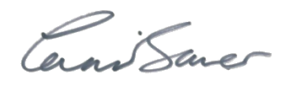
Carina Bauer
CEO, Regent Exhibitions Ltd

