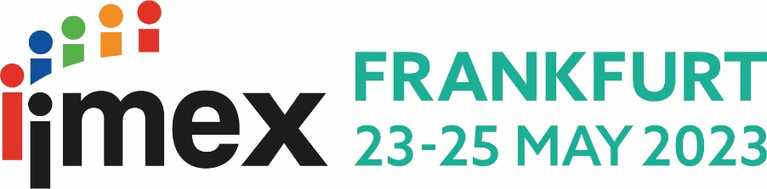

[Your company logo]
[Your programme dates]

Hello [insert Manager’s name]

IMEX in Frankfurt is vibrant and dynamic. It’s the leading global show for business events that takes place from 23-25 May 2023, at Messe Frankfurt. IMEX is an event to see and meet the whole industry at one time and in one place – and I can’t afford to miss it.

It’s totally FREE, and I’ll receive full support from the IMEX team every step of the way. Below are the reasons why I should attend:

- Freedom to choose my own travel and claim a reimbursement (up to the banding limits)
- Complimentary 4/5* accommodation to fit my program dates during the show
- Unrivaled service and support before, during and after the event, at NO cost to our company
- Pre-booked business appointments plus networking opportunities
- Opportunity to join immersive education sessions, with many qualifying for CMP continuing education (CE) clock hours, and some will also be ILEA approved

As part of a hosted buyer team, the approximate cost for me to attend IMEX in Frankfurt will be:
Registration: Zero
Airfare: Zero
Hotel: Zero
Meals:
Other expenses:
Total cost:
You can learn more about IMEX in Frankfurt at imex-frankfurt.com

Thank you for your time. I look forward to hearing from you.
[signature]

