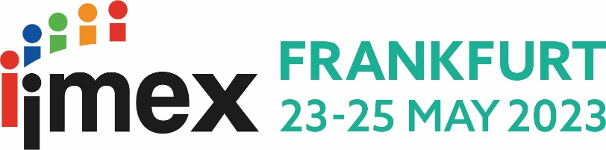

Benefits of attending IMEX in Frankfurt 2023 as a hosted buyer
My reasons for attending IMEX in Frankfurt 2023 are to see and meet the whole business events industry at one time and in one place. This is the perfect opportunity for me to find out the strength of the market, discover what’s new, who’s who, AND make a classic face to face business event work hard for our organisation. I will have the opportunity to maintain established relationships and make new contacts for our business.

This will help me plan for the following events:
Enter details of your upcoming events and/or meetings.
- ……………………………………………………………………………………………………………………………………………………………………………………………………………………………………………………………………………………
- ……………………………………………………………………………………………………………………………………………………………………………………………………………………………………………………………………………………
- ……………………………………………………………………………………………………………………………………………………………………………………………………………………………………………………………………………………
To source suppliers for the above events, I am planning to meet with the following exhibitors at IMEX America: Search the IMEX in Frankfurt exhibitor directory.

- …………………………………………………………………………………………………………………………………………
- …………………………………………………………………………………………………………………………………………
- …………………………………………………………………………………………………………………………………………
- …………………………………………………………………………………………………………………………………………
- …………………………………………………………………………………………………………………………………………
I’m also planning to connect with the following existing and potential suppliers:
Choose the most relevant exhibitors to your organisation and give reasons why you want to meet them.

- …………………………………………………………………………………………………………………………………………
Reason why: ……………………………………………………………………………………………………………………
- …………………………………………………………………………………………………………………………………………
Reason why: ……………………………………………………………………………………………………………………
- …………………………………………………………………………………………………………………………………………
Reason why: ……………………………………………………………………………………………………………………
- …………………………………………………………………………………………………………………………………………
Reason why: ……………………………………………………………………………………………………………………
- …………………………………………………………………………………………………………………………………………
Reason why: ……………………………………………………………………………………………………………………

IMEX in Frankfurt offers countless opportunities to network allowing me to connect with industry colleagues, innovators, speakers, experts, and suppliers in the industry. Events of specific interest to me are listed below.
Explore networking events at IMEX in Frankfurt.

- …………………………………………………………………………………………………………………………………………
- …………………………………………………………………………………………………………………………………………
- …………………………………………………………………………………………………………………………………………
This year’s education program at IMEX in Frankfurt includes sessions touching on important topics for our organisation. I will have the chance to attend sessions covering the following key topics:
Choose the education topics you feel are most relevant to you, your goals and your organisation.
- Event planner toolkit
- Professional development and upskilling
- Creativity in communication
- Diversity, inclusion, equity and accessibility
- Innovation and tech
- Trends and future foresight
- Well-being and personal growth
- Sustainability and nature+
- Purposeful recovery
The expertise and knowledge provided in the above tracks will not only give me access to the latest meeting and event industry trends but will also provide me with professional development opportunities at NO extra cost. Many sessions allow me to earn continuing education hours towards professional certification.
I’m expecting to clock … hours towards my CMP certification/recertification (delete as appropriate).

